|  |
| --- |
| Influence of External Input and Inhibitory Synapses on the Balance of a Sparsely Connected Network |
| Bachelor Thesis Psychobiology |
| theoretical neuroscience2.jpg |
| **Jiri Brummer – 10277897 –** [**jiribrummer@gmail.com**](mailto:jiribrummer@gmail.com)  **Supervisor: Fleur Zeldenrust -** [**fleurzeldenrust@gmail.com**](mailto:fleurzeldenrust@gmail.com)  **Second corrector: Lourens Waldorp -** [**waldorp@uva.nl**](mailto:waldorp@uva.nl)  **12-6-2015** |
|  |

Influence of External Input and Inhibitory Synapses on the Balance of a Sparsely Connected Network

*Jiri Brummer, supervised by Fleur Zeldenrust*

Abstract

Cortical cells *in vivo* typically show irregular firing to sensory stimuli, whereas the same cells show regular firing to injections *in vitro.* To examine the underlying mechanism which causes this irregular behavior, computational models are used. The balanced random network is a large-scale network of sparsely connected Leaky Integrate-and-Fire (LIF) neurons. This network, with the simplest LIF neuron is extensively examined and can reach different states based on synchrony and regularity, including the asynchronous regular state, which resembles human cortical activity. In this thesis it is examined whether a balanced network with a more biological plausible synapse model can reach these states as well, systematically quantifying the network activity on both synchrony and regularity, when the amount of external input and the relative influence of the inhibitory synapses is varied. It is shown that this extended model can reach different states of synchrony and regularity as well, however, within some states the behavior is different. Because these states can be reached, especially the asynchronous irregular state, this model can be used to examine the influence of different biological properties on the behavior of network activity resembling human cortical activity, and therefore give more insight in the computations underlying the human cortical brain.

Introduction

Cortical cells *in vivo* typically show irregular firing in response to sensory stimuli, whereas the same cells show regular firing behavior in response to current injections *in vitro* (Softky & Koch, 1993). How this irregular behavior *in vivo* arises, and what its consequences are, remains a topic for debate. One theory is that if neurons receive a lot of weak presynaptic input, the average input would be constant and therefore the postsynaptic neuron would fire regularly. To explain the irregular firing behavior, either the input should be synchronized or the dendrites should be non linear (Softky & Koch, 1993). A contradictory explanation states that synchronization is not necessary as long as there is a strong balance between excitation and inhibition. As a consequence, the average of the input is subthreshold. Because the input is stochastic, neurons respond to minor deviations from the average, which leads to irregular firing (Shadlen & Newsome, 1998). To examine the underlying mechanism of this irregular firing, often computational models are used.

The balanced random network (Brunel, 2000; Remme & Wadman, 2012; Yger & Harris, 2013), also called balanced network, is a large-scale network of sparsely connected Leaky Integrate-and-Fire (LIF) neurons. It is called balanced, because the network activity neither attenuates nor increases after initialization. The network activity remains constant over time. A LIF neuron uses a linear approximation of the subthreshold membrane potential, and therefore only uses very few parameters. A spike itself is not modeled. The behavior of a balanced network of the simplest LIF neurons is extensively examined, both analytically and computationally (Brunel, 2000).

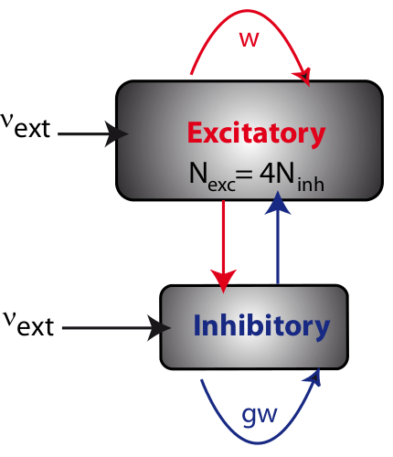Brunel (2000) showed that a balanced network can settle in four different states, which are based on the synchrony of the network and the regularity of single neurons. The network can reach the synchronous regular (SR) state, where single neurons fire regularly with a time constant similar to the refractory period and the network is synchronized. If single neurons fire regularly but the network activity is asynchronous, it is called the asynchronous regular (AR) state. If individual neurons fire irregularly, the network could reach the synchronous irregular (SI) and the asynchronous irregular (AI) states. In which state the network settles depends on the following key parameters: the amount of external input (each neuron receives stochastic background input) and the relative strength of the inhibitory synapses (see Figure 1).

**Figure 1.** **Visualization of a balanced network.** A balanced network with populations of excitatory and inhibitory neurons, each connected both with itself and with each other. Each neuron receives 4 times more excitatory than inhibitory connections. Moreover each neuron receives external input. In this network model, w is the synaptic strength of the excitatory connections, g is the relative weight of the inhibitory connections and is the frequency of the external input . (From Yger, n.d.)

A recent study showed that a network model with more biological plausible LIF neurons, in which the synapse is described in more detail, can reach the asynchronous irregular state as well (Yger & Harris, 2013). However, it is still unknown if this network can reach the different states of synchrony and regularity, and whether the transitions between these states are similar to those of the network with a simpler synapse model. **Therefore, in this thesis I examined whether a network model with more biological plausible synapses can reach the same states as the original network with respect to synchrony and regularity.** The hypothesis was that different balanced states can be reached, although the exact ranges of parameter values at which the transitions occur, will differ from the simpler model.

To examine this hypothesis, I implemented a balanced network of LIF neurons and systematically quantified the regularity of the individual spike trains and the synchrony of the network. Different combinations of two parameters were used: the external input and relative strength of inhibitory synapses, which were the key parameters in Brunel (2000)*.* It was expected that it is possible to differentiate between the four states based on the quantification. Whether the ranges of the parameter values are similar to those in the simpler model is unknown, as the involved parameters also influence parameters not present in the simpler model, and therefore their influence not examined yet.

Materials and Methods

**Simulations**

Simulations of the spiking neural networks were performed using the BRIAN 2 simulator (Goodman & Brette, 2009), with a fixed time step and a membrane time constant of . All simulations were performed on a Packard bell EasyNote TK with 4GB RAM and 2,3 GHz AMD Athlon II P360 processor.

**Simple network model**

For the simple LIF neuron model (adapted from Brunel, 2000*)* the following equation is used:

where is the external input each neuron receives. It is assumed that the external input each neuron receives is an excitatory Poisson spike train with frequency . This external input is described by the following equation:

where represents the mean of the Poisson spike train and is described by the following equation:

,

where is the spike-threshold of the neuron. The second part of the external input, , represents the fluctuations around the mean where is described by

,

where represents the PSP amplitude, represents the number of connections of excitatory neurons and represents Gaussian white noise with mean = 0 and standard deviation (SD) = 1. Besides external input, each neuron receives input from other neurons in the network. The change of the membrane potential is described by:

with

,

where is the change of the postsynaptic membrane potential (*i*) as a consequence of presynaptic spike firing (*j*) and g is the relative strength of a inhibitory synapse ( for excitatory synapses). The other parameter values were kept fixed at the following values: , , the transmission delay , the refractory period and the reset value after a spike , all extracted from Brunel (2000). Because Brunel (2000)showed that variations of the relative strength of the inhibitory synapses and the external firing rate underlie the differentiation between the four states best, I used these as the free parameters which are varied in the simulations.

The number of excitatory (NE) versus inhibitory (NI) neurons are, resembling the ratio of anatomical estimates for the neocortex, 1600 and 400 respectively. The sparseness of the network (ε), which is described by

was 0.1 with a total number of neurons (Brunel, 2000). However, to keep simulations feasible, the number of neurons was scaled down to . As a consequence, the sparseness had to be scaled as well in order to preserve the same balance (Golomb & Hansel, 2000). This new sparseness value is described by:

where , and After application of this scaling, the sparseness of the network = 0.4098. This means that every neuron has a probability of 0.4098 it receives a connection from any other neuron.

**More complex network model**

In the biologically more realistic network, a similar neuron model was used as in Brunel (2000), but the synapses were modeled differently. After a presynaptic spike, not the postsynaptic membrane potential was updated, but the postsynaptic conductance, following a linear differential equation (Yger & Harris, 2013). This conductance change indirectly leads to a change in membrane potential.

In this network model, the membrane potential of each neuron is given by:

,

where is the membrane conductance, here defined as . Remaining parameter values were extracted from Yger & Harris (2013) and kept fixed. These values are as follows: the leak conductance , the resting membrane potential , the threshold , the reset potential and the refractory period .

The synapses were modeled as instant changes in conductance when a spike is triggered, followed by an exponential decay, described by:

and

where the excitatory and inhibitory synaptic time constant are and and reversal potentials are and respectively.

To keep the simulations feasible, 800 excitatory and 200 inhibitory neurons were used, instead of 4500 as used in Yger & Harris (2013). In order to maintain the same level of balance, the sparseness used was = .1915, scaled from .05 as described previously (see simple network model). Synaptic delays are randomly chosen from a uniform distribution between 0.1 and 5 . Initial synaptic conductances were randomly chosen from Gaussian distributions with means and , and standard deviations equal to a third of their means. The value of is kept fixed,   
, whereas the value of is varied in order to examine its influence. Finally, each neuron receives input from an independent Poisson spike train at 300 , through an excitatory synapse with conductance of . Because Brunel (2000) showed that variations of external input and the relative strength of the inhibitory synapses caused different balanced states, I used these parameters in this network model as well. Therefore, the inhibitory conductance, , and the conductance of the external input, , are varied in the simulations.

**Quantification of regularity and synchrony of the more complex model**

For the parameters and exploratory simulations, based on previous studies (Brunel, 2000; Yger & Harris, 2013), were performed in order to determine the range of values for the simulations. Based on these exploratory simulations, the range was set for between 1 and 10 and for between 2 and 11 , as values for result in a network with too little activity. Parameter values greater than the chosen range were left out because they did not show different behavior compared to the highest values within the chosen range.

For these combinations of parameter values, the single neuron activity is quantified for regularity and the network activity for synchrony. The regularity of a network is quantified as the average regularity over its neurons, given by the coefficient of variation (CV) of the inter-spike interval distribution of each spike train:

where is the average CV value of a network, N the number of neurons in the network and ISI the distribution of the inter-spike-intervals for each neuron.

The synchrony of the network is quantified by the following synchrony measure (SM): the average of the three highest peaks of the global network activity is defined as the synchrony peak average (SPA). In order to correct for the total activity of the network, a randomly distributed Poisson spike train, with the same amount of spikes as the network model, is simulated. For this global activity of the Poisson spike train the SPA is calculated as well. Then, the SM is described as follows:

where is the measure for synchrony of the network, is the synchrony peak average of the network model and the synchrony peak average of the Poisson spike train, containing the exact same amount of spikes, but randomly distributed. Assumed that the represents random activity with no synchrony, a high value represents a high level of synchrony.

**Clustering**

After the quantification of both regularity and synchrony is completed, a k-means analysis was performed in order to objectively cluster the different parameter sets into different states (Arthur & Vassilvitskii, 2007). For the determination of the number of clusters, the Elbow method is used (Ketchen Jr. & Shook, 1996). With this method the number of clusters is plotted against the total distance of the points of a cluster to the centre of its cluster. This distance usually decreases as the number of clusters increases. Initially the decrease is high and there usually is a flipping point after which the decrease is much lower. This is called the elbow point and the value of the number of clusters of that point is used for the k-means analysis. For the k-means analysis the regularity and synchrony data are scaled so both variables have the same weight in the determination of clusters. For the scaling each data point is divided by the total of the variable, so the relative distance instead of the absolute distance is used for the analysis.

Results

In order to examine whether the biologically more plausible neuron model can reach different states, based on synchrony and regularity as in Brunel (2000), firstly it was examined whether the scaling has no influence on the network activity and the four states could still be reached. This was the case: the Synchronous Regular (SR) state was reached with . The Synchronous Irregular (SI) state was reached with . The Asynchronous Regular (AR) state was reached with and the Asynchronous Irregular (AI) state was reached with (see Figure 2). Since the smaller network could indeed reproduce the results of Brunel (2000), I proceeded with extending the model with the more complex synapses and examined whether that model could reach these four states as well.

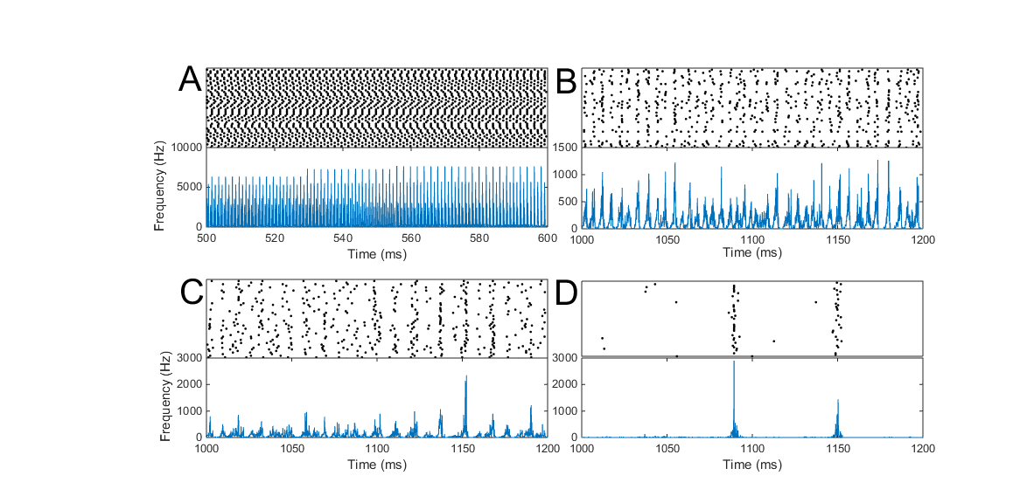To examine the behavior of the activity of the (small) network with the extended synapse model, exploratory simulations were conducted in order to determine the range in which the network activity shows different types of behavior. The initial parameter values of Yger & Harris (2013)were . Since all simulations with showed too little network activity, the ranges used for simulations were for between and and for between 2 and .

**Figure 2.** **Classification of different states of a balanced network of the simple network model.** Simulations of a network of 1600 excitatory and 400 inhibitory neurons with a sparseness of 0.4098. For all four situations the spiking behavior of 50 randomly chosen neurons of the population is shown in the upper plot (each row is a neuron), and the global activity of the network, the average frequency in Hz, is shown in the lower plot. **A.** The Synchronous Regular (SR) state, where neurons are synchronized and neurons spike regularly (only the during refractory period the neurons are silent; ). **B.** The Synchronous Irregular (SI) state, where there is synchrony in the global activity, but single neurons fire irregularly (). **C.** The Asynchronous Regular (AR) state, where the network activity is asynchronous, but single neurons do tend to fire regularly (). **D.** The Asynchronous Irregular (AI) state, where the network activity is asynchronous and single neurons spike irregularly ().

When the external input was increased and the inhibitory synaptic strength was kept low, the network reaches the SR state (see Figure 3A). When the synaptic strength of the inhibitory synapses was increased, roughly between and , the network reaches a state that was not described in the original network by Brunel (2000): a Bursting Synchronous state (BS; see Figure 3B). When inhibition is increased more, the network activity shows a state similar to the AI state (see Figure 3C). The states between de SR and BS states, when , look like transition states (TS; see Figure 3D). However, without quantification it is hard to determine whether there are SI and AR states in these ranges of and . Therefore calculations to quantify regularity and synchrony were performed.

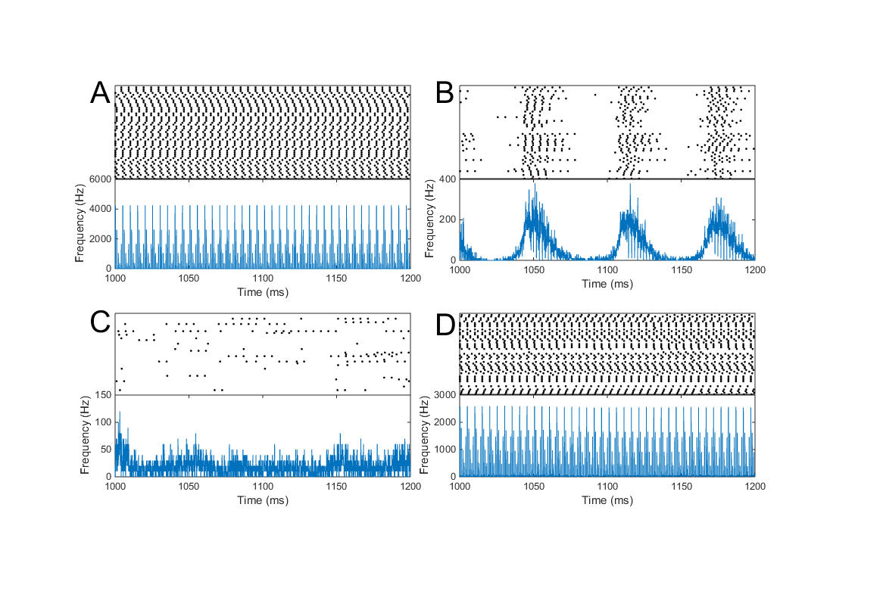To be able to differentiate between the different states objectively, the Coefficient of Variation (CV) and the Synchrony Measure (SM; for both see Methods) were calculated for regularity and synchrony respectively. A low CV value means that the neurons on average spike regularly, CV values around 1 mean that on average the neural spike trains are similar to a Poisson process, and therefore highly irregular. The different values of the CV are plotted in Figure 4A. The figure shows that values of , independent of the value of , all cause very regular spiking behavior. shows moderate regularity, and all values of cause very irregular behavior.

**Figure 3.** **Classification of different states of a balanced network of the more complex network model.** Simulations of a network of 800 excitatory and 200 inhibitory neurons with a sparseness of 0.1915. For all four situations the spiking behavior of 50 randomly chosen neurons of the population is shown in the upper plot (each row is a neuron), and the global activity of the network, the average frequency in Hz, is shown in the lower plot. **A.** The Synchronous Regular (SR) state, where neurons are synchronized and neurons spike regularly (only the during refractory period the neurons are silent; ). **B.** The Bursting Synchronous (BS) state, where there is synchrony within a burst and single neurons fire irregularly (). **C.** The Asynchronous Irregular (AI) state, where the network activity is asynchronous and single neurons spike irregularly . **D.** The Transition State (TS), where some neurons still fire regularly and some are almost silent and fire irregularly. Therefore there is synchrony, but less than the SR state .

For synchrony a similar approach was used: a high SM value signifies synchronous behavior. The SM values are plotted in Figure 4B. Values of show very synchronous behavior. Moreover, for low values of the network shows more synchronous behavior than higher values of . When the measures for regularity and synchrony are combined, the SR state clearly stands out: for the CV values are relatively low and the SM values relatively high. However, classification of other states is harder, because the differences between the CV and SM values are smaller. Therefore, objective clustering was needed.

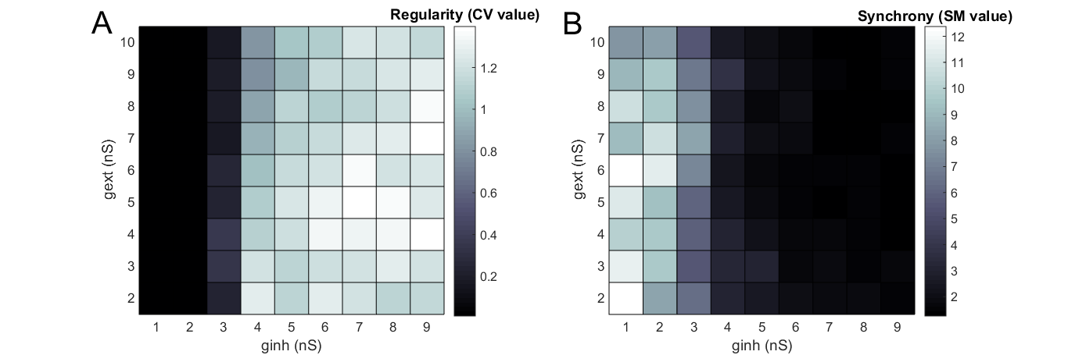For objective clustering, the k-means analysis method is used. This is an algorithm which efficiently distributes the data in *k* clusters, and iterates until the total distance of all data points to the centre of their cluster is minimized (Arthur & Vassilvitskii, 2007). In order to determine the number of clusters, the elbow method is used (see Methods). As shown in Figure 5A, the flipping point is at 5 clusters, so k-means was performed with 5 clusters. The analysis revealed 5 quite clearly separated clusters (see Figure 5B): cluster 1 and 2 are the SR states. The difference between 1 and 2 is merely based on synchrony: the SM values of cluster 1 are between 10.7 and 12.4, whereas the SM values of cluster 2 are between 7.7 and 10.0. However, because both states all have a very low CV value and a high SM value, they were both classified with the SR state. The third cluster is a transition state, where some neurons are still in the SR state whereas others are more silent. The fourth cluster best represents the bursting state: the synchrony is relatively high, but there is little regularity as there are two phases: within and between burst. So the inter-spike-intervals could be short (within bursts) or long (between bursts) and therefore the CV value is high. Cluster five is the AI state, where neurons fire irregularly and the network is asynchronous.

**Figure 4. Plots of the degree of regularity (A) and synchrony (B) of balanced networks with the more complex synapse model with different values of . A.** The regularity of the neurons in the network (CV value) is plotted for the parameter ranges . **B.** The synchrony of the network activity (SM value) is plotted for the parameters ranges .

Discussion

After four different balanced states of the simple small network model were found, I examined whether a more complex synapse model could settle in the same four different states, based on regularity and synchrony. Cluster analysis revealed five clusters, which could be separated in four different states. The synchronous regular state, a transition state, a bursting state and an asynchronous irregular state. The bursting state could also be called a synchronous irregular state. Compared to the simpler network model, the more complex network model lacks the asynchronous regular state, and the synchronous irregular state shows strong bursting behavior. So in conclusion, the more complex model could reach different balanced states, but the behavior differs from the simple network model, as the more complex model shows strong bursting behavior.

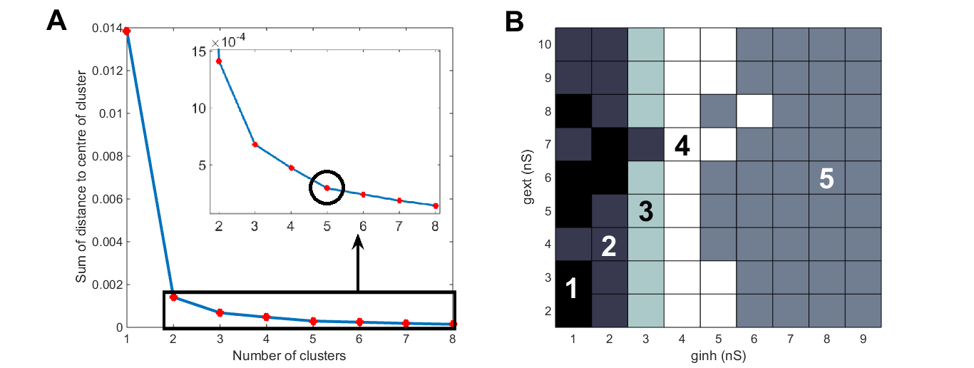This difference in behavior could have several causes. Firstly, the adjusted synapse model, which makes the network more complex, could explain the difference. This conductance model, in which the conductance decays exponentially, causes a long-lasting postsynaptic membrane depolarization after a spike, keeping it close to threshold when a following spike arrives. This positive feedback causes a high frequency firing, hence the initiation of a burst. Since the time constant of the inhibitory synapse is higher, the influence of high frequency firing on inhibitory neurons is bigger than on excitatory neurons, resulting in the termination of the burst after some time. Eventually, when the inhibitory conductance has decayed, the influence of the external input is strong enough to initialize a burst again.

**Figure 5.** **K means analysis of the more complex neuron model in order to cluster parameter values into groups based on regularity and synchrony. A.** The elbow method is shown: on the y-axis the total distance of all data to the centre of its cluster. The flipping point is at 5 clusters, which means that 5 clusters were used for the k-means analysis. **B.** The output of the k-means analysis is shown. Five clusters are grouped based on regularity and synchrony. Cluster 1 and 2 are the Synchronous Regular (SR) state, cluster 3 is a Transition State (TS), cluster 4 is the Bursting Synchronous (BS) state and cluster 5 is the Asynchronous Irregular (AI) state.

Besides this explanation, there is another difference between the extended network and the original network from Brunel (2000), which could have a major influence: the more complex network model has initial conductance weights drawn from a Gaussian distribution, whereas in the original model all weights are the same. This distribution of conductance values causes that there are neurons with low conductance and neurons with high conductance. This means that when increases, some neurons with a high initial conductance of external input still receive enough external input to fire regularly, whereas the neurons with a lower conductance receive too little external input and their firing rate decreases. This causes that some neurons still fire regularly whereas other fire irregularly. This causes less overall regularity and synchrony, but still enough to prevent entering the bursting state. This is the transition state, where only a part of the neurons behave as if they are in the SR state, and is only visible in the extended network model.

Thirdly, network size could have an effect as well. It is examined whether the scaling had influence on the network behavior. It looked like there was no difference in activity between the original network size and the scaled network. However, this was only examined for the original network of Brunel (2000). Whether the scaling influences the extended network model is unknown. Moreover, the measure for synchrony depends on the number of spikes per time step. So in a smaller network, fluctuations of the firing behavior of single neurons have more influence on the synchrony measure than in a larger network. Therefore a larger network might provide more reliable results for synchrony.

Finally, there are several parameters used with fixed values for the simulations, for example duration of refractory period and synaptic delay. These values were extracted from Yger & Harris (2013). Given that these values differ from the original network of Brunel (2000), it should be taken in account that they have influenced the network activity and therefore also might (partial) underlie the different behavior of the extended model.

The simple network model, thoroughly examined by Brunel (2000)*,* was used to examine irregular behavior of a network in order to examine the causes of irregular neural activity in the human brain. In this study, an adaptation of the model of Yger & Harris (2013) is quantified to examine regularity and synchrony of this extended network model, and appears to behave as an asynchronous irregular network as well. As this is a more biological plausible network, it could be used to examine the influence of different biologically relevant properties on the behavior of certain neural networks, such as synaptic strength, the connectivity of a brain area and the length of axons/ dendrites, here represented in synaptic delays.

Future studies can show the influence of these biological relevant properties on especially the asynchronous irregular state. As this is the state which resembles human cortical activity the most, understanding what properties cause a distortion of the balance might help understanding diseases where this balance is impaired, for example epilepsy. Furthermore, more realistic components of neurons or synapses can be added to the model and their influence examined. With the continuing growth of the computational power, more detailed models of neurons can be connected in large-scale networks and simulations can still be run in a reasonable time. This could give more insight in how these networks behave and this will result in a better understanding of the computations made in the human brain.

In this thesis, I examined whether a extended network model can reach balanced states similar to Brunel (2000). It was shown that this more complex model shows states similar to Brunel (2000), but also shows different behavior: the bursting state. This different behavior is due to extra biological plausible characteristics. This model, and extensions of it, can be used to examine influence of different parameters, such as synaptic strength, synaptic delay and the connectivity of the network, on the network activity. Especially the influence on the asynchronous irregular state is interesting, as this resembles the activity of the human cortical. Future research can help to understand the underlying mechanisms of this activity and therefore get more insight in the computations of the human cortical brain.

References

Arthur, D., & Vassilvitskii, S. (2007). k-means++: The advantages of careful seeding. *Proceedings of the Eighteenth Annual ACM-SIAM Symposium on Discrete Algorithms*, 1027–1035. http://doi.org/10.1145/1283383.1283494

Brunel, N. (2000). Dynamics of sparsely connected networls of excitatory and inhibitory neurons. *Computational Neuroscience*, *8*, 183–208.

Golomb, D., & Hansel, D. (2000). The number of synaptic inputs and the synchrony of large, sparse neuronal networks. *Neural Computation*, *12*(5), 1095–1139. http://doi.org/10.1162/089976600300015529

Goodman, D. F. M., & Brette, R. (2009). The brian simulator. *Frontiers in Neuroscience*, *3*(SEP), 192–197. http://doi.org/10.3389/neuro.01.026.2009

Ketchen Jr., D. J., & Shook, C. L. (1996). The application of cluster analysis in strategic management research: An analysis and critique. *Strategic Management Journal*, *17*(6), 441–458. http://doi.org/10.1002/(SICI)1097-0266(199606)17:6<441::AID-SMJ819>3.0.CO;2-G

Remme, M. W. H., & Wadman, W. J. (2012). Homeostatic scaling of excitability in recurrent neural networks. *PLoS Computational Biology*, *8*(5). http://doi.org/10.1371/journal.pcbi.1002494

Shadlen, M. N., & Newsome, W. T. (1998). The variable discharge of cortical neurons: implications for connectivity, computation, and information coding. *The Journal of Neuroscience : The Official Journal of the Society for Neuroscience*, *18*(10), 3870–3896.

Softky, W. R., & Koch, C. (1993). The highly irregular firing of cortical cells is inconsistent with temporal integration of random EPSPs. *The Journal of Neuroscience : The Official Journal of the Society for Neuroscience*, *13*(1), 334–350.

Yger, P. (n.d.). The Balanced Network. Retrieved May 29, 2015, from http://www.yger.net/the-balanced-network/

Yger, P., & Harris, K. D. (2013). The Convallis Rule for Unsupervised Learning in Cortical Networks. *PLoS Computational Biology*, *9*(10). http://doi.org/10.1371/journal.pcbi.1003272